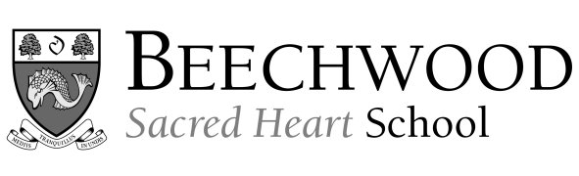
An Independent School for Girls and Boys aged 3 – 18.

Required for April or September 2019

DEPUTY HEAD
Senior School

We seek to appoint a teacher with vision, experience and talent to join the senior management team at Beechwood Sacred Heart School. The successful candidate will be an enthusiastic educationalist with a proven record of outstanding teaching and whole school management experience. Non-Catholic candidates would be expected to support the Catholic ethos of the school. This is an exciting opportunity to join Beechwood in a key role at a transformational time in the School’s hundred year history. Further details and an application pack are available from:

Head’s Secretary, Beechwood Sacred Heart School, 12 Pembury Road, Tunbridge Wells, Kent, TN2 3QD. Tel: 01892 532747; Fax: 01892 536164; email: bsh@beechwood.org.uk; website: www.beechwood.org.uk

Closing Date: Noon 28 November 2018

Beechwood is committed to safeguarding and promoting the welfare of children and applicants will undergo appropriate child protection screening including checks with past employers and the DBS.

Registered charity number: 325104

